User manual



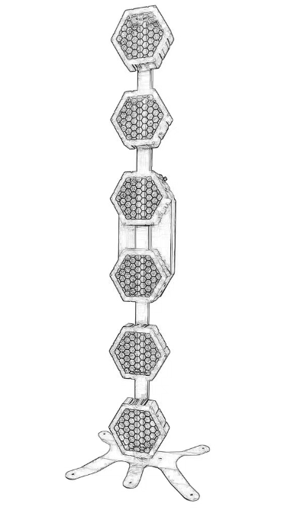
P2 RETRO LIGHT
Please read the instructions carefully before use

TABLE OF CONTENTS
- Safety Instructions………………………………………………………………………………3
- Technical Specifications…………………………………………………………………………4
- Control Menu ………………………………………………………………………………………4
- DMX Channels ……………………………………………………………………………………5-6
- Trouble Shooting……………………………………………………………………………………7
- Fixture Cleaning………………………………………………………… …………………………7

STATEMENT
The product has well capability and intact packing when leave factory. All of the user should comply with warning item and manual, any misuse cause of the damages are not included in our guarantee, and also can not be responsible for any malfunction & problem owing to ignore the manual.

1.Safety Instructions
Please keep this User Guide for future consultation. If you sell the unit to another user, be sure that they also receive this instruction booklet.
•Unpack and check carefully there is no transportation damage before using the unit.
•Before operating, ensure that the voltage and frequency of power supply match the power requirements of the unit.
•It’s important to ground the yellow/green conductor to earth in order to avoid electric shock.
•The unit is for indoor use only. Use only in a dry location.
•The unit must be installed in a location with adequate ventilation, at least 50cm from adjacent surfaces. Be sure that no ventilation slots are blocked.
•Disconnect main power before replacement or servicing.
•Make sure there are no flammable materials close to the unit while operating as it is fire hazard.
•Use safety cable when fixes this unit. DO NOT handle the unit by taking its head only, but always by taking its base.
•Maximum ambient temperature is Ta: 40℃. DO NOT operate it where the temperature is higher than this Unit surface temperature may reach up to 85℃. DO NOT touch the housing bare-hand during its operation. Turn off the power and allow about 15 minutes for the unit to cool down before replacing or serving.
•the event of serious operating problem, stop using the unit immediately.Never try to repair the unit by yourself. Repairs carried out by unskilled people can lead to damage or malfunction. Please contact the nearest authorized technical assistance center. Always use the same type spare parts.
•DO NOT touch any wire during operation as high voltage might be causing electric shock.
Warning:
•To prevent or reduce the risk of electrical shock or fire, do not expose the unit to rain or moisture.
•The housing, the lenses, or the ultraviolet filter must be replaced if they are visibly damaged.
Caution:
•There are no user serviceable parts inside the unit. DO NOT open the housing or attempt any repairs yourself. In the unlikely event your unit may require service, please contact your nearest dealer.
Installation:
•The unit should be mounted via its screw holes on the bracket. Always ensure that the unit is firmly fixed to avoid vibration and slipping while operating. And make sure that the structure to which you are attaching the unit is secure and is able to support a weight of 10 times of the unit’s weight. Also always use a safety cable that can hold 12 times of the weight of the unit when installing the fixture.
•The equipment must be fixed by professionals. And it must be fixed at a place where is out of the touch of people.

2.Technical Specifications
SPECIFICATIONS:
Light Source: 6*60W & 144*0.2w 3in1 led
Input Voltage:AC90-260V 50/60Hz
Power Consumption: 420W
Control mode:DMX512,Auto-run , Master-Slave
Control Channel: 8/28 channels
Powercon:powercon in & out
DMX sockets:3-pin XLR sockets
Display: Digital Display
Strobe：1-25t/s multiple stroboscopic effect
Dimming：0-100% linear dimmer
3.Control Menu
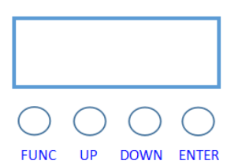

Menu Operation
On the base of the control panel offers a number of features, such as setting DMX fixture address, switch the lamp, run the test program, the mode selection.
No | Show | Instruction
1 | A001 | 001-512
2 | Channel | 8CH
2 | Channel | 28CH
3 | DMX512,Auto-run , Master-Slave | DMX512,Auto-run , Master-Slave
4.DMX Channels
8 DMX channels
CH 8 | DMX Value | Function | Function Illustration
1 | 0－255 | Total Dimmer | Total Dimmer
2 | 0－3 | Strobe | No function
2 | 4－255 | Strobe | Slow to fast
3 | 0-255 | Red | R Dimmer dark to light
4 | 0-255 | Green | G Dimmer dark to light
5 | 0-255 | Blue | B Dimmer dark to light
6 | 0-255 | White | W Dimmer dark to light
7 | 0-9 | Function | No function
7 | 10-19 | Function | Effect 1
7 | 20-29 | Function | Effect 2
7 | … | Function | 10 numbers one effect
7 | 240-249 | Function | Effect 24
7 | 250-255 | Function | Effect 25
8 | 0-63 | speed | static
8 | 64-159 | speed | Forward running speed from fast to slow
8 | 160-255 | speed | Reverse running speed from slow to fast
28 DMX channels
CH 28 | DMX Value | Function | Function Illustration
1 | 0－255 | Total Dimmer | Total Dimmer
2 | 0－3 | Strobe | No function
2 | 4－255 | Strobe | Slow to fast
3 | 0-255 | Red 1 | R1 Dimmer dark to light
4 | 0-255 | Green1 | G1 Dimmer dark to light
5 | 0-255 | Blue1 | B1 Dimmer dark to light
6 | 0-255 | White1 | W1 Dimmer dark to light
7 | 0-255 | Red2 | R2 Dimmer dark to light
8 | 0-255 | Green2 | G2 Dimmer dark to light
9 | 0-255 | Blue2 | B2 Dimmer dark to light
10 | 0-255 | White2 | W2 Dimmer dark to light
11 | 0-255 | Red3 | R3 Dimmer dark to light
12 | 0-255 | Green3 | G3 Dimmer dark to light
13 | 0-255 | Blue3 | B3 Dimmer dark to light
14 | 0-255 | White3 | W3 Dimmer dark to light
15 | 0-255 | Red4 | R4 Dimmer dark to light
16 | 0-255 | Green4 | G4 Dimmer dark to light
17 | 0-255 | Blue4 | B4 Dimmer dark to light
18 | 0-255 | White4 | W4 Dimmer dark to light
19 | 0-255 | Red5 | R5 Dimmer dark to light
20 | 0-255 | Green5 | G5 Dimmer dark to light
21 | 0-255 | Blue5 | B5 Dimmer dark to light
22 | 0-255 | White5 | W5 Dimmer dark to light
23 | 0-255 | Red6 | R6 Dimmer dark to light
24 | 0-255 | Green6 | G6 Dimmer dark to light
25 | 0-255 | Blue6 | B6 Dimmer dark to light
26 | 0-255 | White6 | W6 Dimmer dark to light
27 | 0-9 | Function | No function
27 | 10-19 | Function | Effect 1
27 | 20-29 | Function | Effect 2
27 | … | Function | 10 numbers one effect
27 | 240-249 | Function | Effect 24
27 | 250-255 | Function | Effect 25
28 | 0-63 | speed | static
28 | 64-159 | speed | Forward running speed from fast to slow
28 | 160-255 | speed | Reverse running speed from slow to fast

5.Trouble Shooting
Following are a few common problems that may occur during operation. Here are some suggestions for easy troubleshooting:

A. The unit does not work, no light and the fan does not work
1. Check the connection of power and main fuse.
2. Measure the mains voltage on the main connector.
3. Check the power on LED.

B. Not responding to DMX controller
1. DMX LED should be on. If not, check DMX connectors, cables to see if link properly.
2. If the DMX LED is on and no response to the channel, check the address settings and DMX polarity.
3. If you have intermittent DMX signal problems, check the pins on connectors or on
PCB of the unit or the previous one.
4. Try to use another DMX controller.
5. Check if the DMX cables run near or run alongside to high voltage cables that may cause damage or interference to DMX interface circuit.
C. One of the channels is not working well
1. The stepper motor might be damaged or the cable connected to the PCB is broken.
2. The motor’s drive IC on the PCB might be out of condition
6.Fixture Cleaning
The cleaning of internal and external optical lenses and/or mirrors must be carried out periodically to optimize light output. Cleaning frequency depends on the environment in which the fixture operates: damp, smoky or particularly dirty surrounding can cause greater accumulation of dirt on the unit’s optics.
• Clean with soft cloth using normal glass cleaning fluid.
• Always dry the parts carefully.
• Clean the external optics at least every 20 days. Clean the internal optics at least every 30/60 days.

